Animal Welfare in Construction & Architecture — European Standards
EU minimum-space standards (Directive 2010/63/EU) with EU ⇄ USA comparison — SI units
Scope & which standard applies
The concrete European minimum-space tables come from Directive 2010/63/EU (protection of animals used for scientific purposes), Annex III — the most precise EU figures available. For companion/pet animals the governing instruments are the Council of Europe Convention for the Protection of Pet Animals (ETS 125) plus national codes, which set principles rather than fixed m² tables. Where EU and USA values differ, the greater value should be taken as the working minimum.
EU minimum enclosure space (Directive 2010/63/EU)
- Dog: minimum enclosure 4.0 m² for dogs ≤ 20 kg, 8.0 m² for dogs > 20 kg; minimum height 2.0 m; outside runs to be provided where possible.
- Cat: floor 0.50 m² (+ 0.25 m² per additional adult), shelf area 2.0 m², minimum height 1.5 m — EU emphasises vertical/shelf space.
- Horse (equids, by withers height WH): 9.0 m² (WH 1.0–1.4 m), 12.0 m² (WH 1.4–1.6 m), 16.0 m² (WH > 1.6 m) per animal held singly/in small groups; foaling box 16–20 m²; minimum enclosure height 3.0 m.
EU ⇄ USA comparison — minimum enclosure space
Case | EU — Directive 2010/63/EU | USA — AWA 9 CFR §3 | Key difference
Dog ≤ 20 kg | Enclosure 4.0 m²; height 2.0 m. | ≈ 0.74–1.20 m² per animal; height ‘stand erect’. | EU ~3–5× more floor; fixed 2 m height.
Dog > 20 kg | Enclosure 8.0 m²; height 2.0 m. | ≥ 2.40 m² per animal. | EU much larger fixed enclosure.
Cat (adult) | Floor 0.50 m² + shelf 2.0 m²; height 1.5 m. | Floor 0.28–0.37 m² + shelf 0.61 m²; height 0.61 m. | EU stresses vertical space; 1.5 m vs 0.61 m high.
Horse (WH 1.4–1.6 m) | 12.0 m² per animal; height 3.0 m; foaling 16–20 m². | 12.96 m² (WH ≥ 1.48 m); height not set. | Similar floor; EU sets 3 m height + foaling box.
Climate & indoor/outdoor design (universal)
- Indoor: enclosed shell, mechanical ventilation, isolation rooms, acoustic control.
- Outdoor: runs, shade, weather shelter, floor slope + drainage, secure fencing.
- Tropical / hot-humid: maximise cross-ventilation; stilts/raised floors; deep shade; light roofs; lightweight low-thermal-mass walls; evaporative cooling.
- Non-tropical / cold: insulation, sealed envelope, heating, thermal mass, solar orientation, snow/rain roof loads.
- Materials & sanitation: non-porous, washable, durable, drainable surfaces; one-way clean→dirty zoning (intake · quarantine · medical · housing · socialisation).
Comparison figure
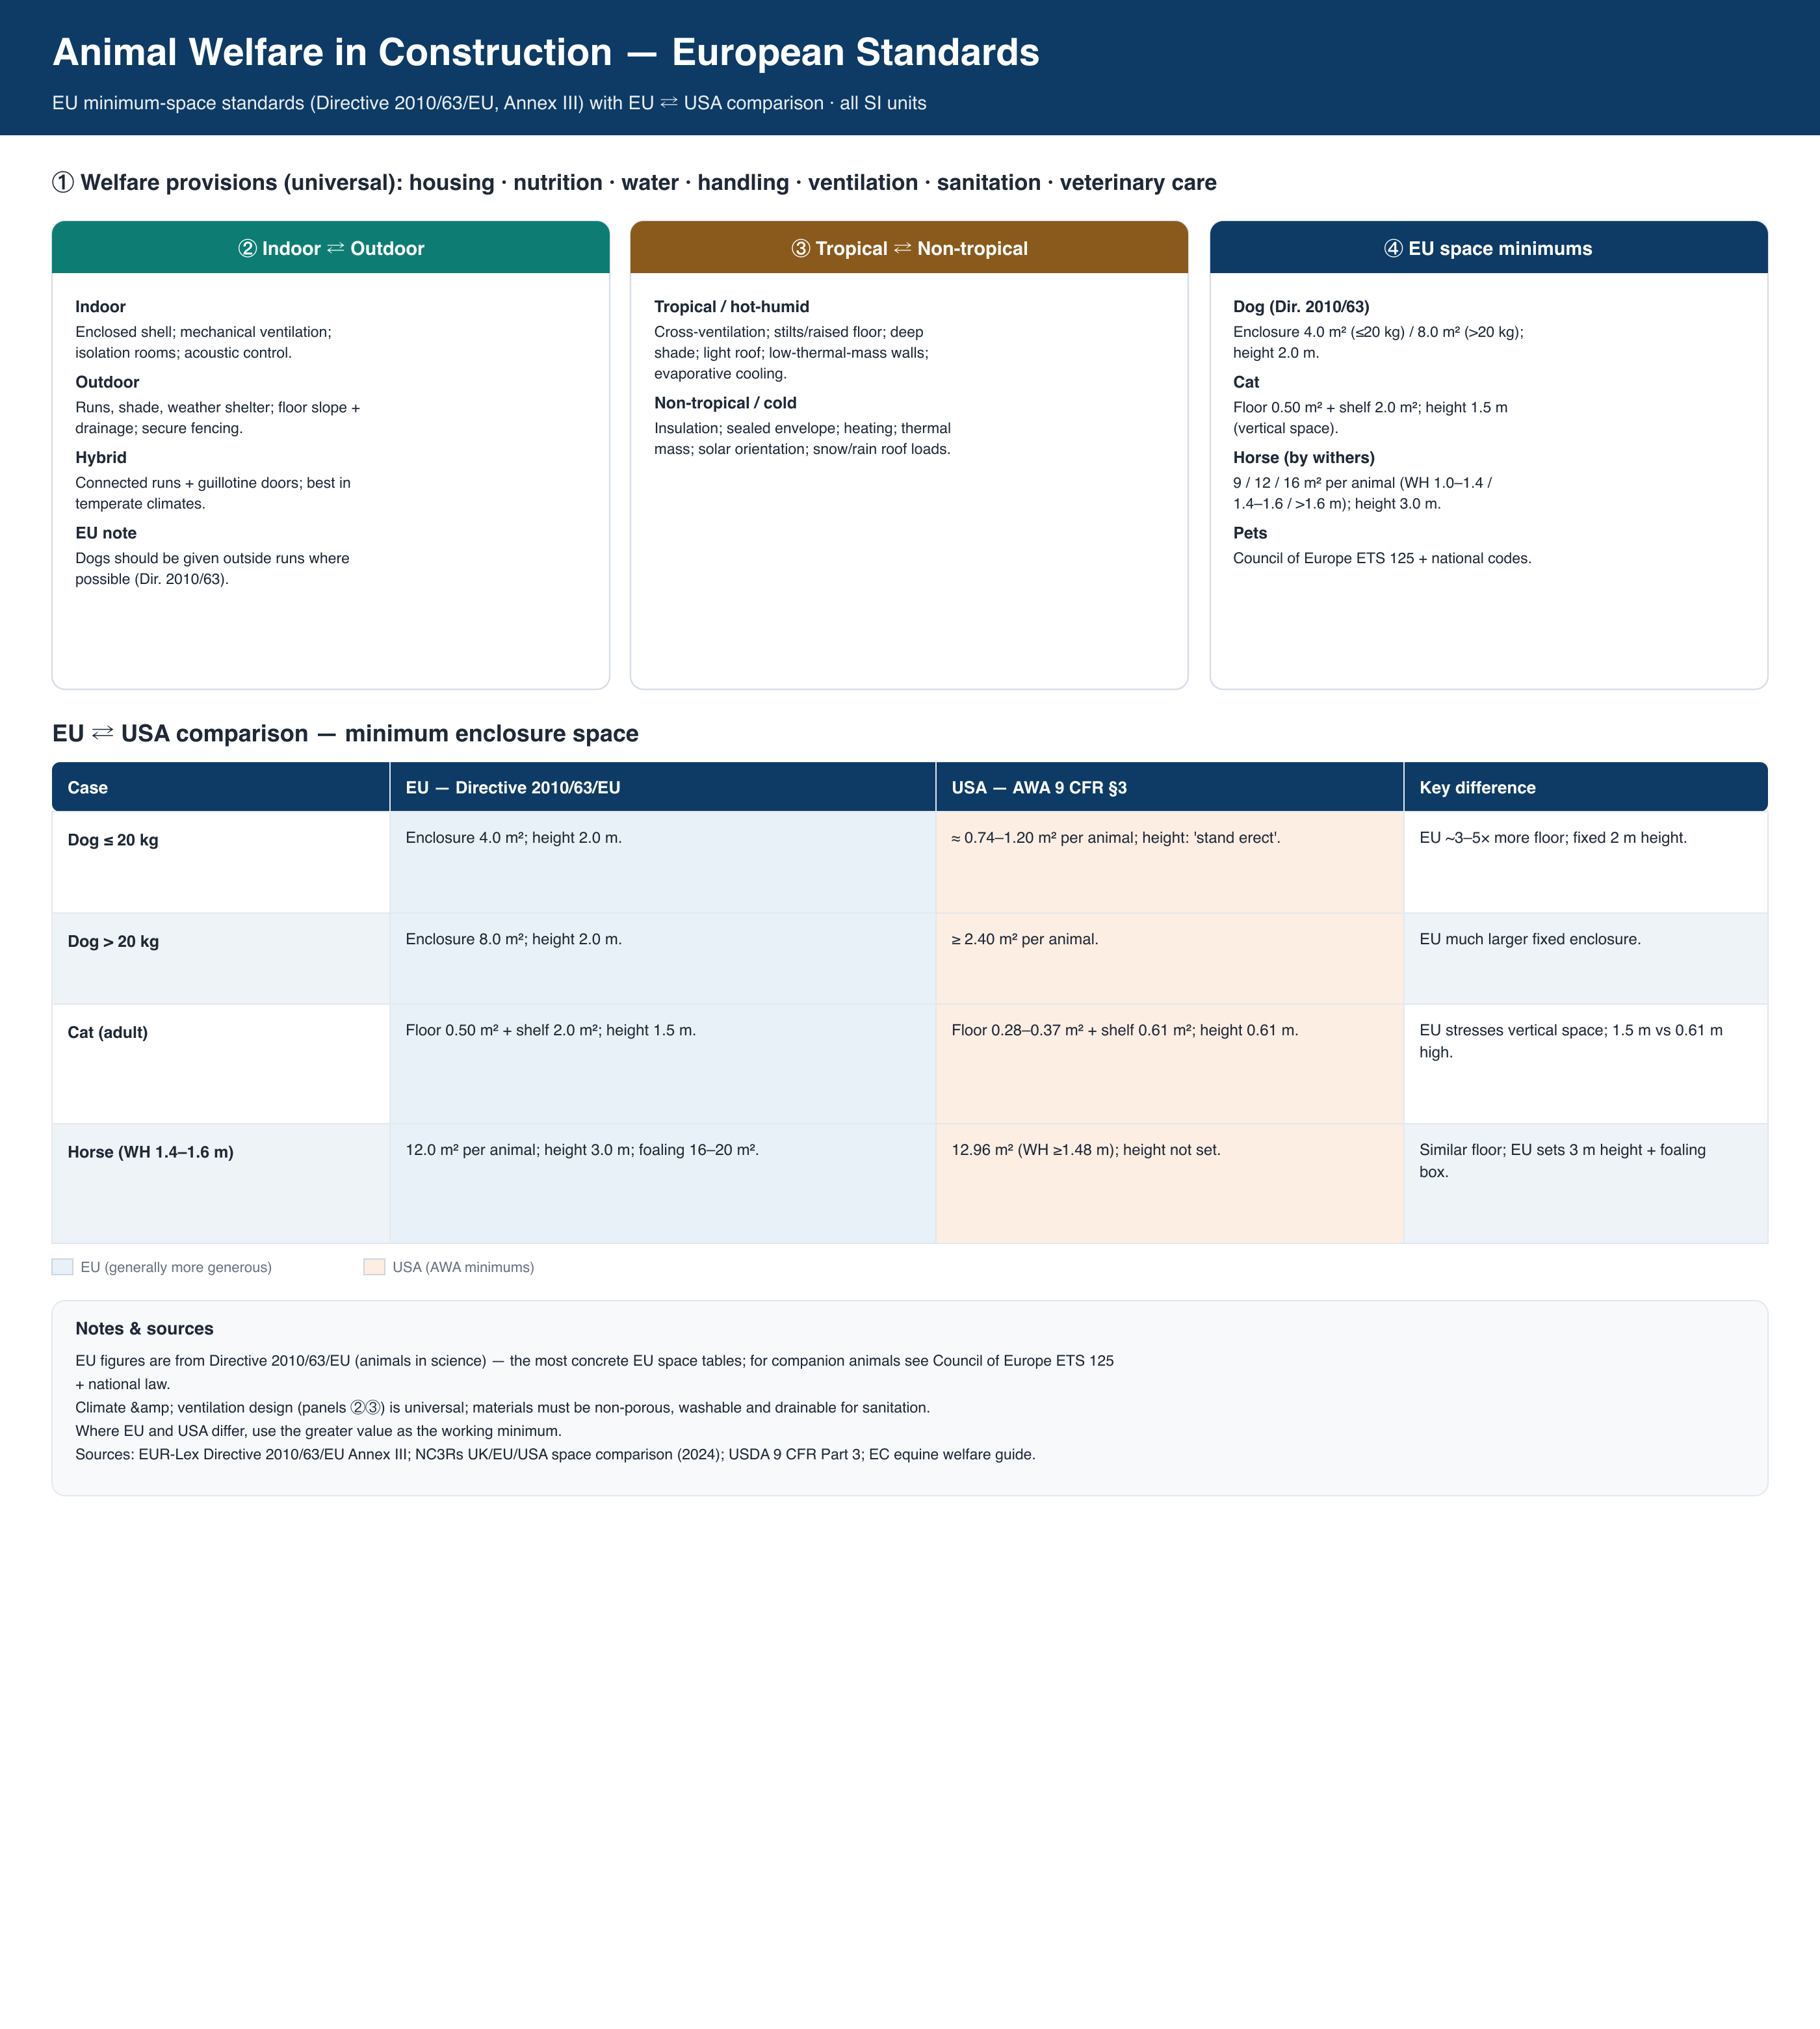
Sources
- EUR-Lex — Directive 2010/63/EU, Annex III (minimum space tables): eur-lex.europa.eu/eli/dir/2010/63
- NC3Rs — Minimum space allocations for laboratory animals: comparison of UK, EU and USA guidance (2024)
- Council of Europe — Convention for the Protection of Pet Animals (ETS 125)
- European Commission — Guide to good animal welfare practice for keeping horses
- USDA — Animal Welfare Act, 9 CFR Part 3 (US comparison values)

