Animal Welfare in Construction & Architecture
Design framework, standards & decision matrix — metric (SI) units
Overview
Animal welfare in housing is defined (USDA) by three dimensions: biological health, emotional state, and the ability to express natural behaviour. In construction and architecture terms, the legal floor is set by the Animal Welfare Act (7 U.S.C. §1752; technical specifications in 9 CFR Part 3). These mandatory provisions are constant, but the way each is built changes with three design variables: indoor vs outdoor, tropical vs non-tropical climate, and species.
① Mandatory provisions — Animal Welfare Act 7 U.S.C. §1752(a)(2)
- Housing — space allocation and materials
- Nutrition — feeding stations and feed storage
- Water — supply points and plumbing
- Handling — circulation and functional zones
- Ventilation — airflow and air quality
- Sanitation — drainage and washable surfaces
- Veterinary care — medical and isolation rooms
② Indoor ⇄ Outdoor
- Indoor: enclosed shell; mechanical ventilation; isolation/quarantine rooms; acoustic/stress control.
- Outdoor: runs, shade, weather shelter; floor slope and drainage; secure fencing.
- Hybrid (indoor–outdoor): connected runs with guillotine doors; best in temperate climates.
- Temperature band for dogs/cats: 7–29.5 °C (45–85 °F), not exceeded for more than 4 consecutive hours.
③ Tropical ⇄ Non-tropical
- Tropical / hot-humid: maximise cross-ventilation; elevation/stilts and raised floors; deep shading; light-coloured roofs; lightweight, low-thermal-mass walls; evaporative/tunnel cooling; insect and humidity/mould control.
- Non-tropical / temperate-cold: insulation and a sealed envelope; heating and draught control; thermal mass to retain warmth; solar orientation; snow/rain roof loads.
④ Species standards (metric)
- Dog — primary-enclosure floor ≈ (body length + 15 cm)² → m² (from AWA formula); clear height ≥ head + 15 cm; non-porous surfaces, drainage, kennel + exercise run; noise control.
- Cat — enclosure ≥ 61 cm high; floor ≥ 0.28 m² (≤ 4 kg) or ≥ 0.37 m² (> 4 kg); vertical space, hiding spots, low-stress cattery layout.
- Horse — stall 3.6 × 3.6 m (≈450–540 kg horse); ceiling ≥ 3.0–3.6 m; 4–8 air changes/hour; mechanical ventilation ≈ 42 / 170 / 340–595 m³/h per 450 kg (cold/mild/hot); non-slip flooring.
Decision matrix — Species × Climate × Indoor/Outdoor
Species | Min space / temp / ventilation | Tropical (hot-humid) | Temperate / cold | Indoor ⇄ Outdoor
Dog | Floor ≈ (length + 15 cm)² → m²; head + 15 cm. 7–29.5 °C; mechanical vent if enclosed. | Shaded open runs, cross-ventilation, raised hose-down floor, drainage. | Insulated, heated kennel block; draught control. | Kennel + exercise run via guillotine door.
Cat | ≥ 0.28–0.37 m² per cat; ≥ 61 cm high. 7–29.5 °C; quiet, low air-speed. | Shaded, ventilated cattery; insect screens; vertical airflow. | Warm indoor cat rooms; community/condo layout. | Indoor rooms + screened ‘catio’ runs.
Horse | Stall 3.6 × 3.6 m; ceiling ≥ 3.0–3.6 m. 4–8 ACH; mech ≈ 42 / 170 / 340–595 m³/h per 450 kg. | Open-sided barn, ridge venting, deep shade, light roof. | Draught-free but ridge + eave vents; insulated roof. | Stall + paddock / turnout access.
Cross-cutting construction principles
- Materials: non-porous, washable, durable, drainable — the basis of sanitation and disease control.
- Air: ventilation sized to species and climate (passive cross-ventilation → mechanical/tunnel + evaporative).
- Water: supply points + graded floors + drainage feeding waste management.
- Light: natural light for circadian rhythm; controlled artificial light.
- Zoning: intake · quarantine/isolation · medical · housing · socialisation — one-way clean→dirty flow.
- Welfare goal: biological health + emotional state + ability to express natural behaviour.
Framework diagram
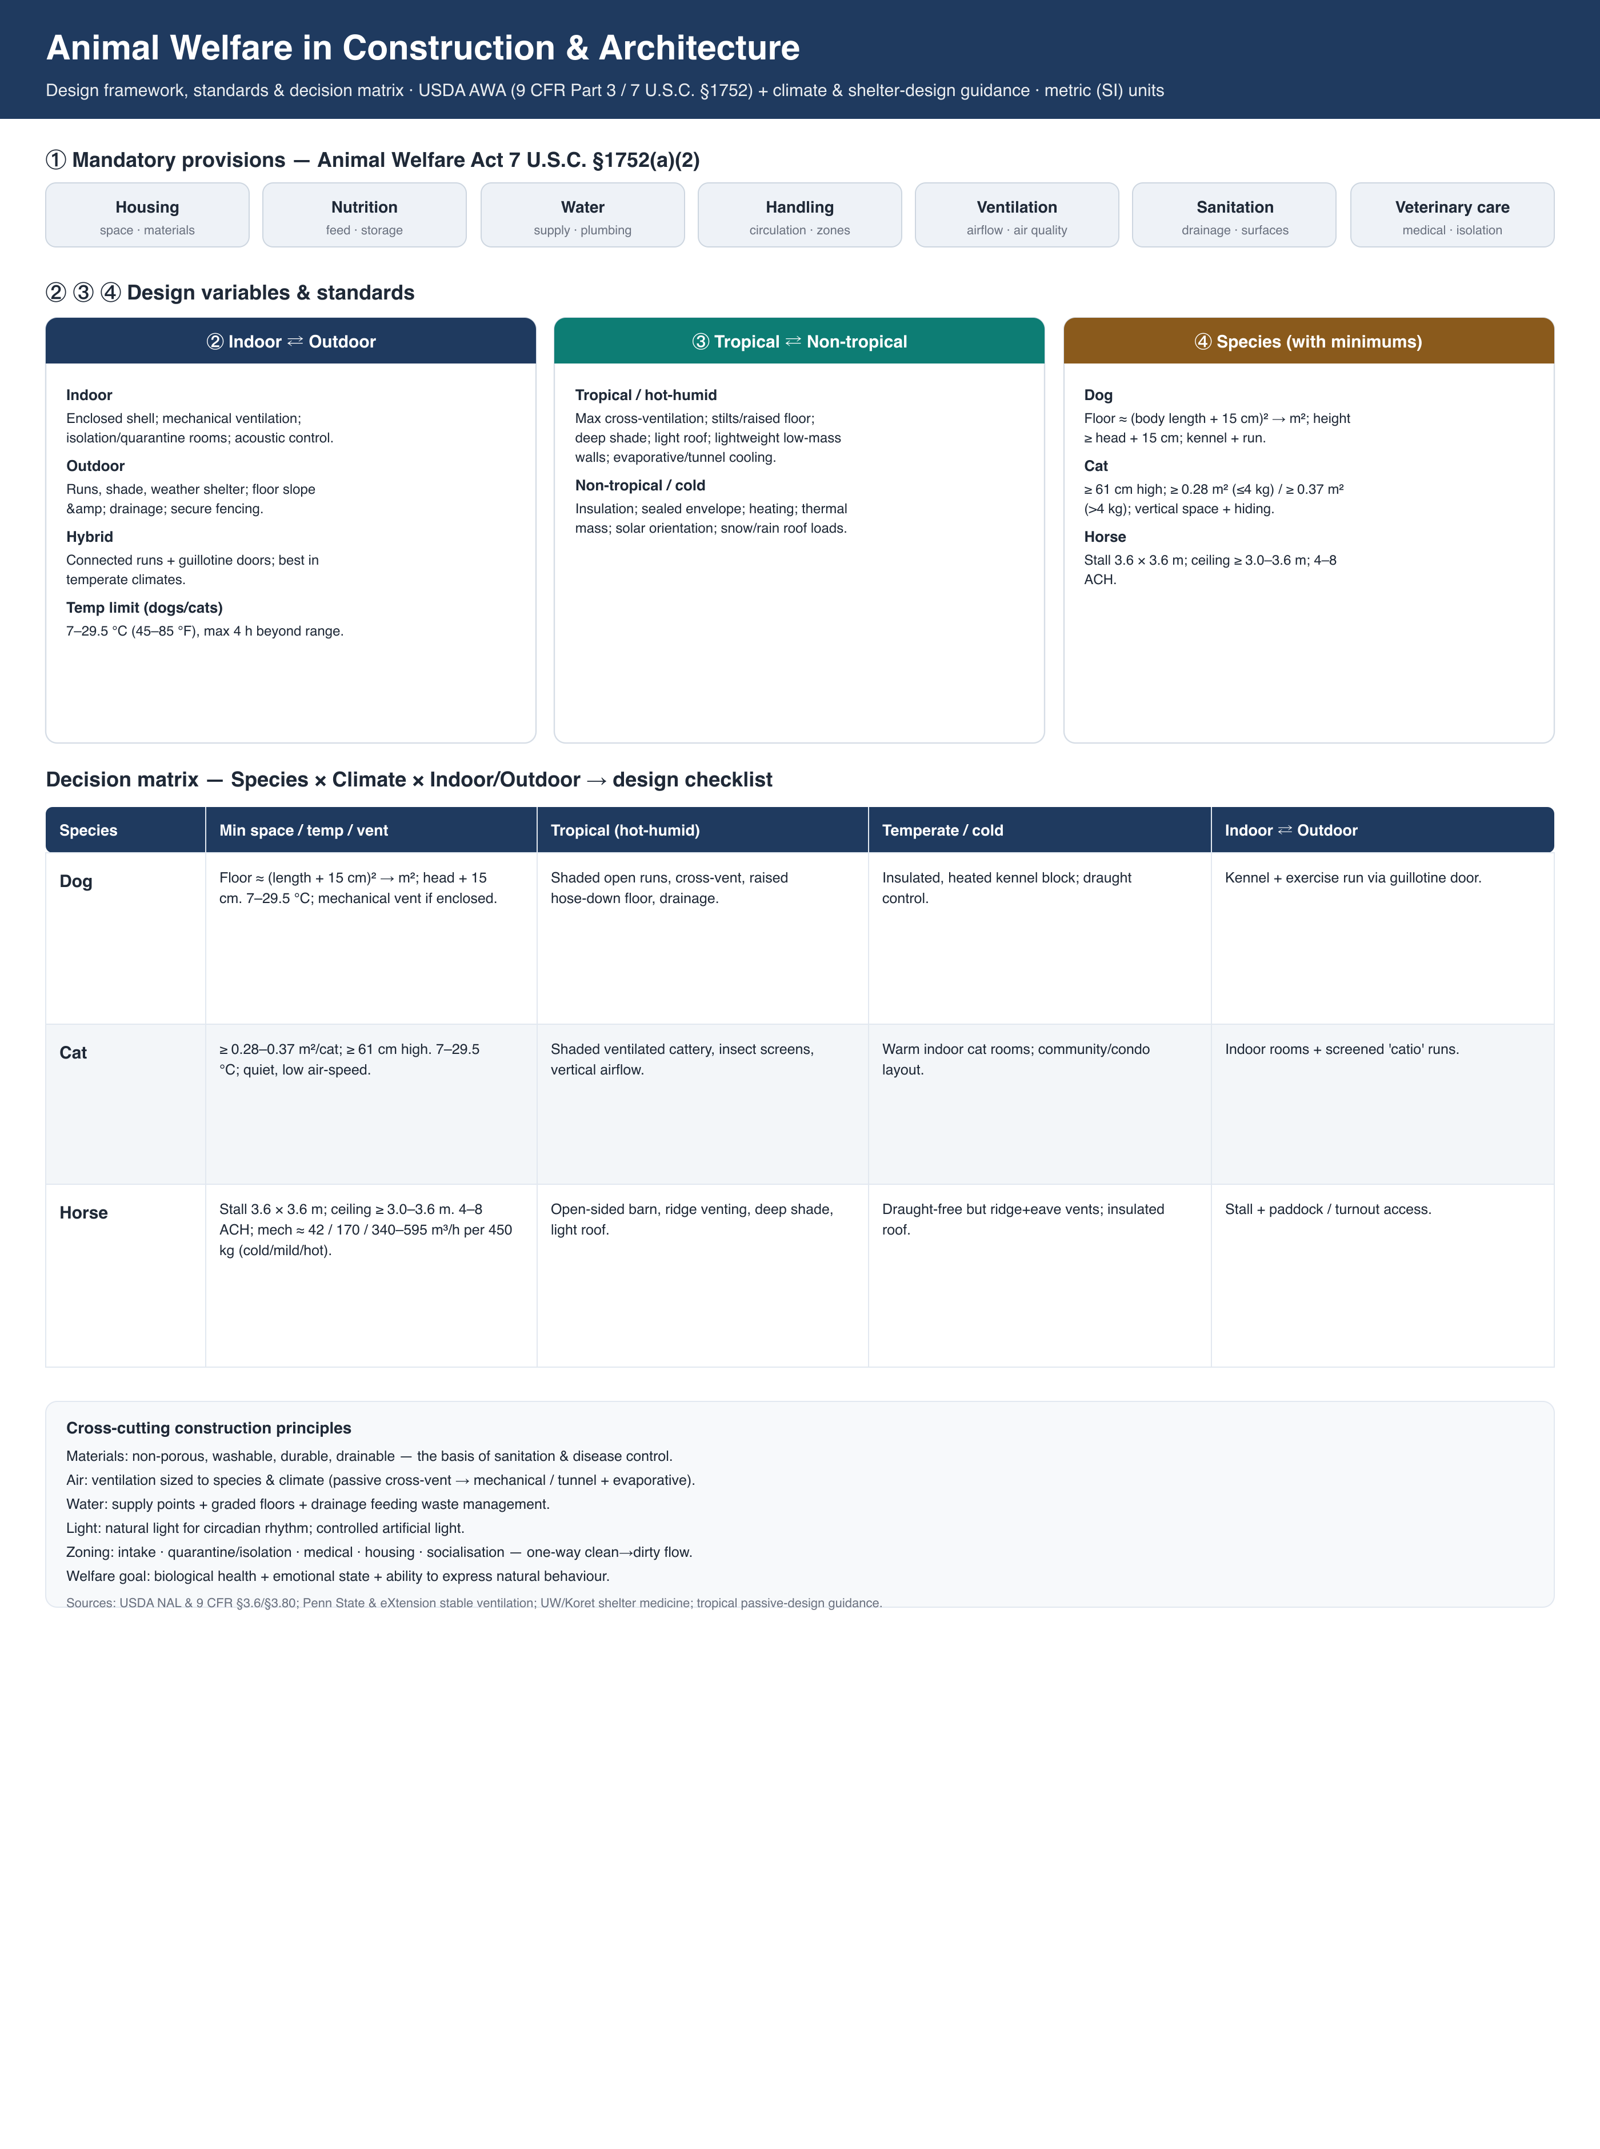
Sources
- USDA NAL — Animal Housing, Care & Welfare (AWA 7 U.S.C. §1752): nal.usda.gov/animal-health-and-welfare/animal-housing-care-welfare
- 9 CFR §3.6 (dogs & cats, primary enclosures) — ecfr.gov; APHIS Minimum Space Requirements for Dogs
- Penn State Extension & eXtension — Horse Stable Ventilation
- UW–Madison & Koret Shelter Medicine — Facility Design & Animal Housing
- Housing for Health — Passive design in tropical zones; FAO — Animal housing environmental requirements (Ch.10)

